January 23, 2024

Chief Bill Scott
San Francisco Police Department
1245 3rd Street, 6th Floor
San Francisco, CA 94158

Dear Chief Scott,

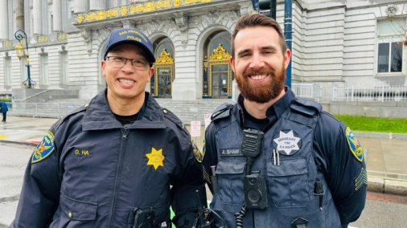
I am writing to thank you for the wonderful conduct of your officers at the 20th Annual Walk for Life West Coast on January 20, 2024. I attended with my family and it was heartwarming to see so many kind and professional members of the SFPD there to protect us and keep the peace. And they did it with smiles on their faces!

We felt not only safe but also very happy to see the good police officers, who seemed to feel good themselves!

It seems like so many people say bad things about the police, never considering the difficulties you and the officers’ face, but you will never hear that from us.

We value and respect you, and don’t know what we’d do without you!

Sincerely,

